TABLE OF CONTENTS

CHAPTER PAGE

Type chapter title (level 1)1

Type chapter title (level 1)1

Type chapter title (level 1)1

Type chapter title (level 1)1

Type chapter title (level 1)1

Type chapter title (level 1)1

Type chapter title (level 1)1

Type chapter title (level 1)1

Type chapter title (level 1)1

Type chapter title (level 1)1

Type chapter title (level 1)1

Type chapter title (level 1)1

Type chapter title (level 1)1

Type chapter title (level 1)1

Type chapter title (level 1)1

Type chapter title (level 1)1

Type chapter title (level 1)1

Type chapter title (level 1)1

Type chapter title (level 1)1

Type chapter title (level 1)1

Type chapter title (level 1)1

Type chapter title (level 1)1

Type chapter title (level 1)1

Type chapter title (level 1)1

Type chapter title (level 1)1

Type chapter title (level 1)1

Type chapter title (level 1)1

Type chapter title (level 1)1

Type chapter title (level 1)1

Type chapter title (level 1)1

Type chapter title (level 1)1

Type chapter title (level 1)1

Type chapter title (level 1)1

Type chapter title (level 1)1

Type chapter title (level 1)1

Type chapter title (level 1)1

Type chapter title (level 1)1

Type chapter title (level 1)1

Type chapter title (level 1)1

Type chapter title (level 1)1

Type chapter title (level 1)1

Type chapter title (level 1)1

TABLE OF CONTENTS

SAMPLE

CHAPTER PAGE

I. INTRODUCTION ..................................................................................................1

II. LITERATURE REVIEW ........................................................................................5

Occupational Therapy's Philosophical Base 5

Purposeful Activity 8

The Professional Activity 9

The Role of Physical Agent Modalities in Occupational Therapy 12

Trends in Physical Disability Area of Practice 15

III. METHODOLOGY 24

Subjects and Setting 24

Data Collection Technique 25

Statistical Analysis 27

Limitations of the Study30

IV. RESULTS 34

Characteristics of Respondents 34

PAMS Used 35

How PAMS were used 36

Treatment Stage 38

V. DISCUSSION49

Research Questions 49

Occupational Performance Frame of Reference 50

Controversy 52

Summary 54

Recommendations 56

LIST OF REFERENCES 60

APPENDICES 66

VITA74

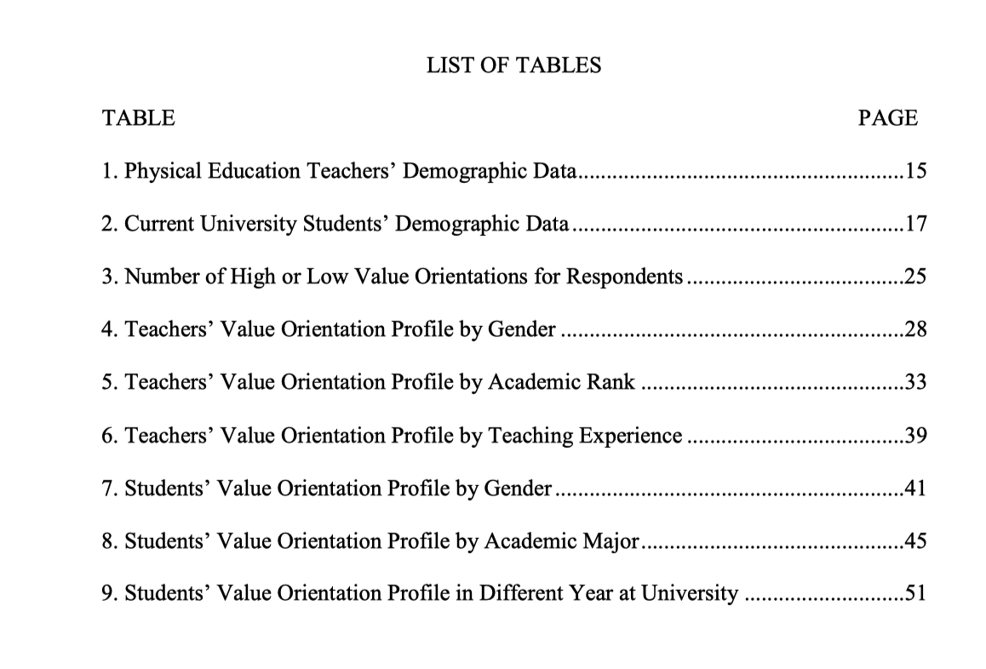

SAMPLE

SAMPLE

SAMPLE